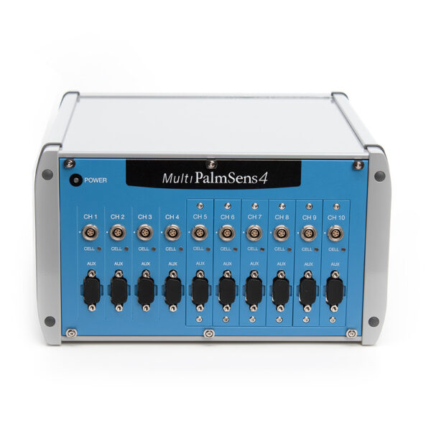
 | Channel 1 | Channel 2 | Channel 3 | Channel 4 | Channel 5 | Channel 6 | Channel 7 | Channel 8 | Channel 9 | Channel 10
Potential Range  (select one) | ☐  ± 5 V | ☐  ± 5 V | ☐  ± 5 V | ☐  ± 5 V | ☐  ± 5 V | ☐  ± 5 V | ☐  ± 5 V | ☐  ± 5 V | ☐  ± 5 V | ☐  ± 5 V
Potential Range  (select one) | ☐  ± 10 V | ☐  ± 10 V | ☐  ± 10 V | ☐  ± 10 V | ☐  ± 10 V | ☐  ± 10 V | ☐  ± 10 V | ☐  ± 10 V | ☐  ± 10 V | ☐  ± 10 V
Electrochemical Impedance Spectroscopy Range (select one) | ☐  No EIS | ☐  No EIS | ☐  No EIS | ☐  No EIS | ☐  No EIS | ☐  No EIS | ☐  No EIS | ☐  No EIS | ☐  No EIS | ☐  No EIS
Electrochemical Impedance Spectroscopy Range (select one) | ☐  100 kHz EIS | ☐  100 kHz EIS | ☐  100 kHz EIS | ☐  100 kHz EIS | ☐  100 kHz EIS | ☐  100 kHz EIS | ☐  100 kHz EIS | ☐  100 kHz EIS | ☐  100 kHz EIS | ☐  100 kHz EIS
Electrochemical Impedance Spectroscopy Range (select one) | ☐  1 MHz EIS | ☐  1 MHz EIS | ☐  1 MHz EIS | ☐  1 MHz EIS | ☐  1 MHz EIS | ☐  1 MHz EIS | ☐  1 MHz EIS | ☐  1 MHz EIS | ☐  1 MHz EIS | ☐  1 MHz EIS
Bipotentiostat Module  (select to add) | ☐  Bipot Module | ☐  Bipot Module | ☐  Bipot Module | ☐  Bipot Module | ☐  Bipot Module | ☐  Bipot Module | ☐  Bipot Module | ☐  Bipot Module | ☐  Bipot Module | ☐  Bipot Module
iR Compensation Module  (select to add) | ☐  iR Comp | ☐  iR Comp | ☐  iR Comp | ☐  iR Comp | ☐  iR Comp | ☐  iR Comp | ☐  iR Comp | ☐  iR Comp | ☐  iR Comp | ☐  iR Comp

☐ Galvanic Isolation of each channel

